1920’s and Great Depression Skills Test Review Activity
Document 1: Document 2:
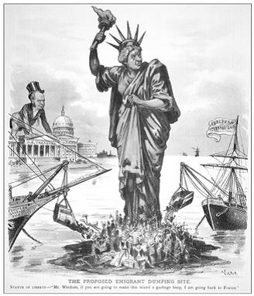
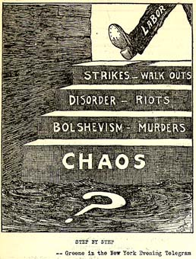
Document 3: Document 4:
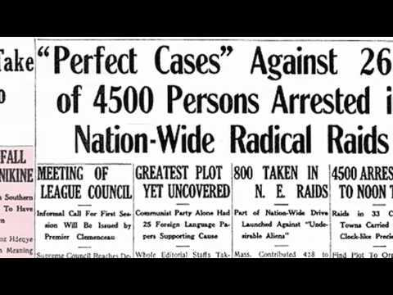
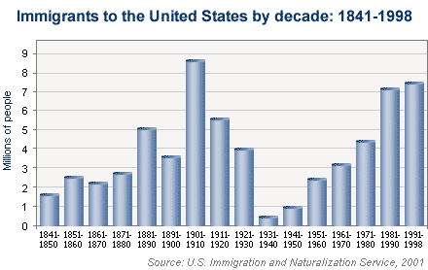
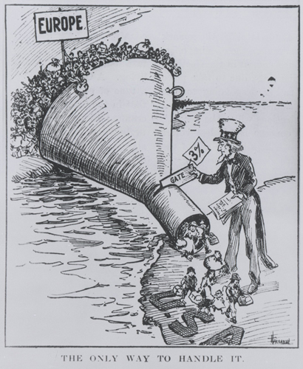
Document 5:

I b

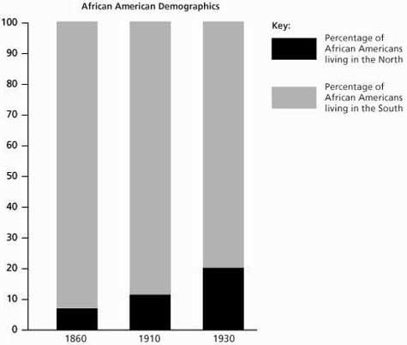
Document 6: Document 7:
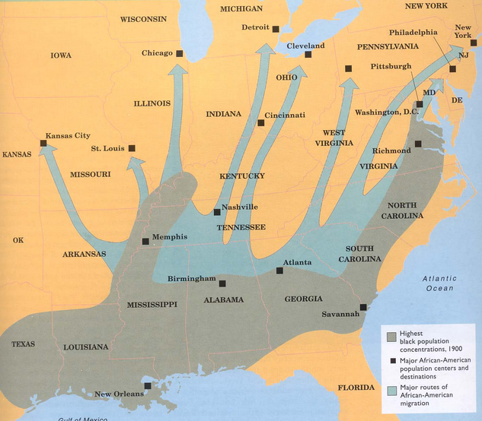

Document 8: Document 9:
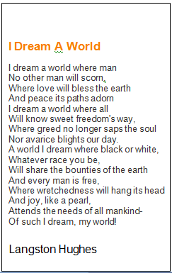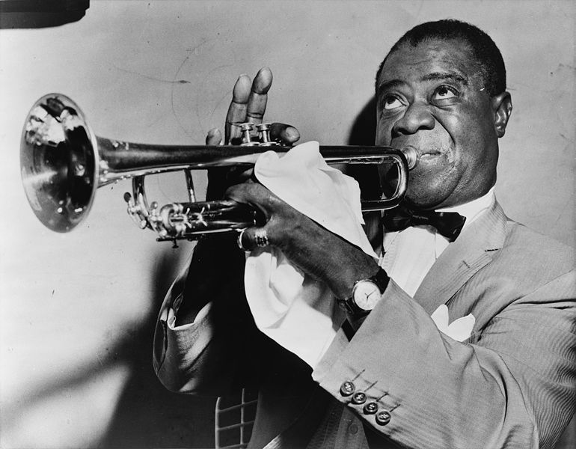
Document 10:
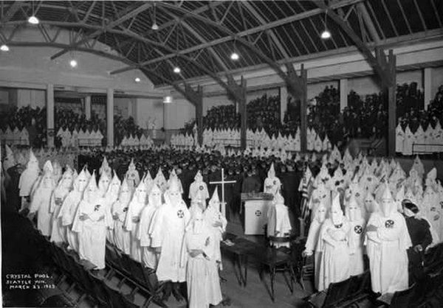
Document 11 (THIS ENTIRE PAGE)
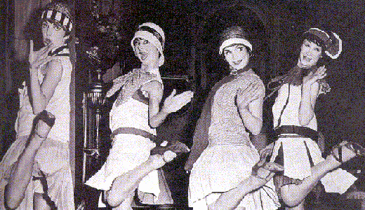
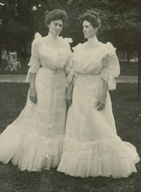
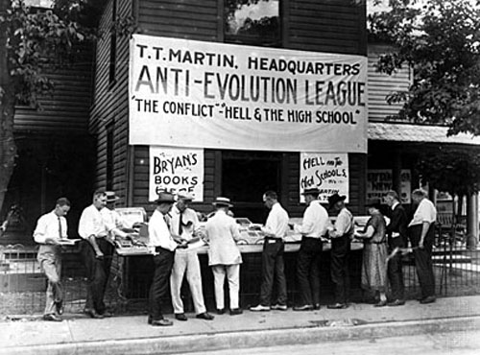
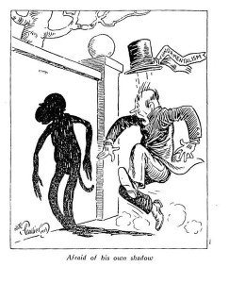

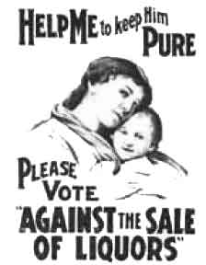
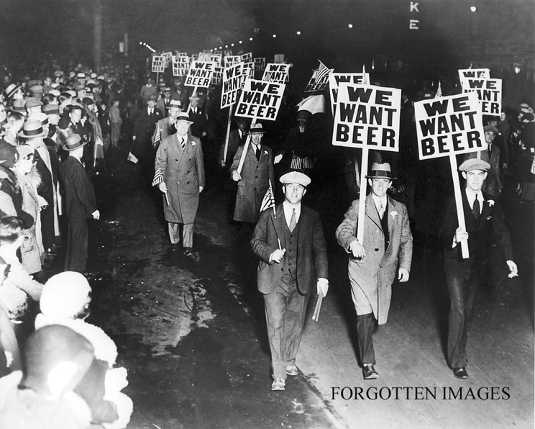

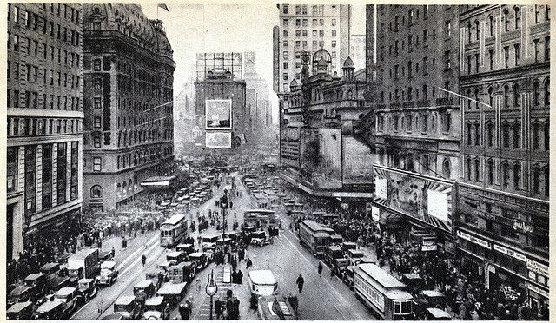
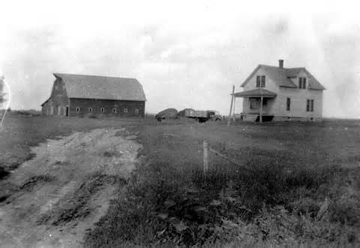

Document 12: Document 13:
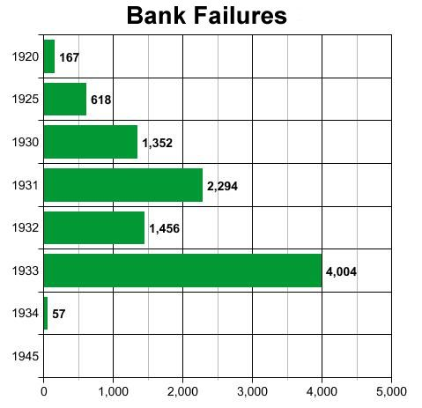
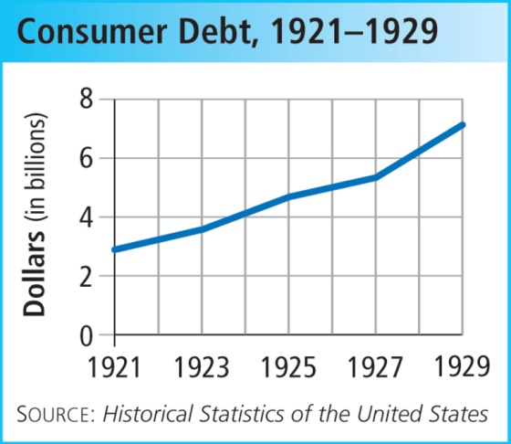

Document 14: Document 15:
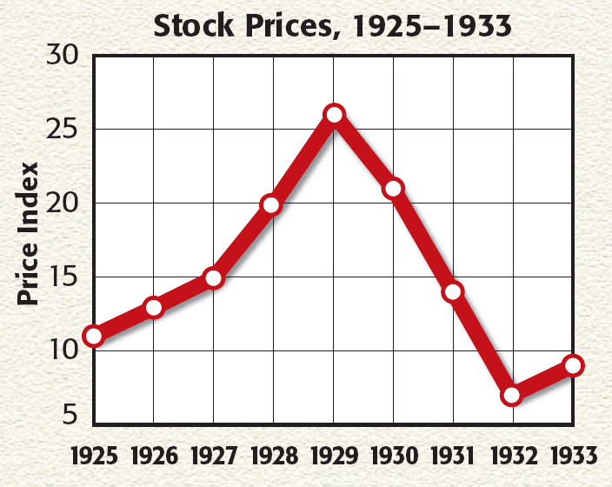
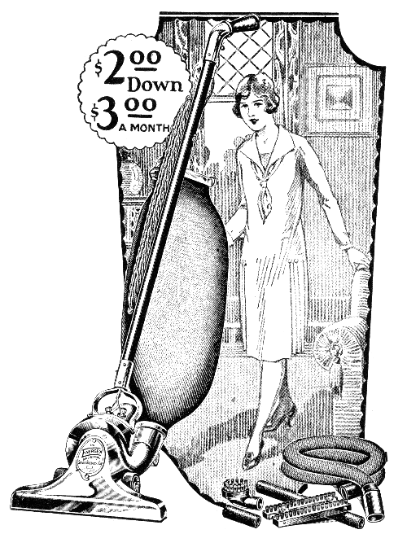

ITEM 16:
1. ______ RELIEF
2. ______ RECOVERY
3. ______ REFORM
a) long-term programs designed to make necessary changes to the economy (such as to the banking system, social welfare programs, etc.) in order to prevent future economic
b) medium-term programs intended to create future economic growth by passing laws to help business, labor and agriculture get strong once again
c) short-term programs to ease/end the suffering of the needy by providing money, loans to make mortgage payments, or jobs

Document 17:
Act or Program | Acronym | Year Enacted | Significance
**Agricultural  Adjustment Act | AAA | 1933 | Protected farmers from price drops by providing crop subsidies to reduce production, educational programs to teach methods of preventing soil erosion. It helped to raise farm prices by reducing the production of crops
Civil Works Administration | CWA | 1933 | Provided public works jobs at $15/week to four million workers in 1934.
**Civilian  Conservation  Corps | CCC | 1933 | Sent 250,000 young men to work camps to perform reforestation and conservation tasks. Removed surplus of workers from cities, provided healthy conditions for boys, provided money for families.
Federal Emergency Relief Act | FERA | 1933 | Distributed millions of dollars of direct aid to unemployed workers.
**Glass-Steagall  Act | FDIC | 1933 | Created federally insured bank deposits ($2500 per investor at first) to prevent bank failures. It was created to re-establish confidence in the American banking system
National Industrial Recovery Act | NIRA | 1933 | Created NRA to enforce codes of fair competition, minimum wages, and to permit collective bargaining of workers.
National Youth Administration | NYA | 1935 | Provided part-time employment to more than two million college and high school students.
Public Works Administration | PWA | 1933 | Received $3.3 billion appropriation from Congress for public works projects.
Rural Electrification Administration | REA | 1935 | Encouraged farmers to join cooperatives to bring electricity to farms. Despite its efforts, by 1940 only 40% of American farms were electrified.
Securities and Exchange Commission | SEC | 1934 | Regulated stock market and restricted margin buying.
**Social Security  Act |  | 1935 | Response to critics (Dr. Townsend and Huey Long), it provided pensions, unemployment insurance, and aid to blind, deaf, disabled, and dependent children. It remains an example of the government’s increased role in the lives of the American people.
Tennessee Valley Authority | TVA | 1933 | Federal government built series of dams to prevent flooding and sell electricity. First public competition with private power industries
Wagner Act | NLRB | 1935 | Allowed workers to join unions and outlawed union-busting tactics by management.
Works Progress Administration | WPA | 1935 | Employed 8.5 million workers in construction and other jobs, but more importantly provided work in arts, theater, and literary projects.
Document 18:
I want to talk for a few minutes with the people of the United States about banking—with the comparatively few who understand the mechanics of banking but more particularly with the overwhelming majority who use banks for the making of deposits and the drawing of checks. I want to tell you what has been done in the last few days, why it was done, and what the next steps are going to be….By the afternoon of March 3 scarcely a bank in the country was open to do business. Proclamations temporarily closing them in whole or in part had been issued by the Governors in almost all the States.
It was then that I issued the proclamation providing for the nationwide bank holiday, and this was the first step in the Government's reconstruction of our financial and economic fabric …This law also gave authority to develop a program of rehabilitation of our banking facilities.…
Your Government does not intend that the history of the past few years shall be repeated. We do not want and will not have another epidemic of bank failures.
As a result, we start tomorrow, Monday, with the opening of banks in the twelve Federal Reserve Bank cities.
Franklin D. Roosevelt, March 12, 1933, First Fireside Chat

Document 19:
Identify each idea with the president associated with it. Write the letter in the corresponding circle below.

A. preferred a hands-off approach to the economy
B. used some degree (even a little bit) of deficit spending
C. created public works projects
D. placed significant emphasis on community members and private organizations to primarily handle the crisis
E. made the creation of permanent federal social programs a reality
F. Criticized for how he handled Great Depression
G. placed heavy emphasis on the concept of “rugged individualism”
H. attempted to influence how the Supreme Court ruled on Great Depression-related issues
I. believed that significant changes needed to be made to the existing economic situation
J. believed that the federal government had a role to play in improving the lives of the American people

HOOVER | BOTH | ROOSEVELT

