“Start of the Great Depression”

Skills Activity

**Document 1: Document 2:**

Some **further examples of electric home appliances and music player prices** in the 1920's and how much they cost  
  
1920-2 ¼ Qt. Double Boiler$1.19 seen in Green Bay Press Gazette, WI

9 Cup Colonial Percolator Coffee Pot$1.19 seen in Green Bay Press Gazette, WI 1921

Western Electric Clothes Washer $125.00 seen in Green Bay Press Gazette, WI 1921

Electric Toaster Green $6.75 seen in Green Bay Press Gazette, WI 1924

Aluminum Coffee Percolators 98¢seen in Green Bay Press Gazette, WI 1924

Electric Table Stoves $1.95 to $12.50 seen in Green Bay Press Gazette, WI 1924

Columbia Grafanola Wind up Gramophone $85 Ohio 1921

**Motor Driven Brush and Suction Cleaner**   
Price: $28.95   
Description This cleaner not only uses suction to lift the dirt and dust it also includes a motor driven brush to help remove dust and dirt from the carpet before the suction lifts the dirt into the bag

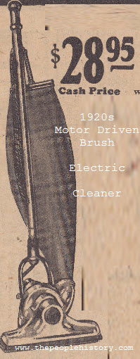

**Document 3: Document 4:**

**Your Radio Itself**   
Price: From $75,00   
Description Radios were priced about $60.00 upwards depending on the number of valves etc.

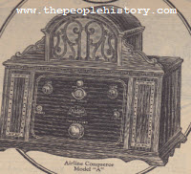

**1928 Chrysler 75 Roadster**   
Price: $1,555   
Description The new Chrysler 75 Roadster for 1928, one the most attractive cars of our times made by master craftsmen entering a new era in design and craftsmanship.



|  |  |
| --- | --- |
| **Number of Radios** | |
| 1900 | 18 per 1,000 people |
| 1910 | 82 per 1,000 people |
| 1920 | 123 per 1,000 people |
| 1930 | 163 per 1,000 people |

**Document 5: Document 6:**

|  |  |
| --- | --- |
| **Sales of Radios** | |
| 1922 | $60 million |
| 1929 | $842.6 million |

**Document 7:**

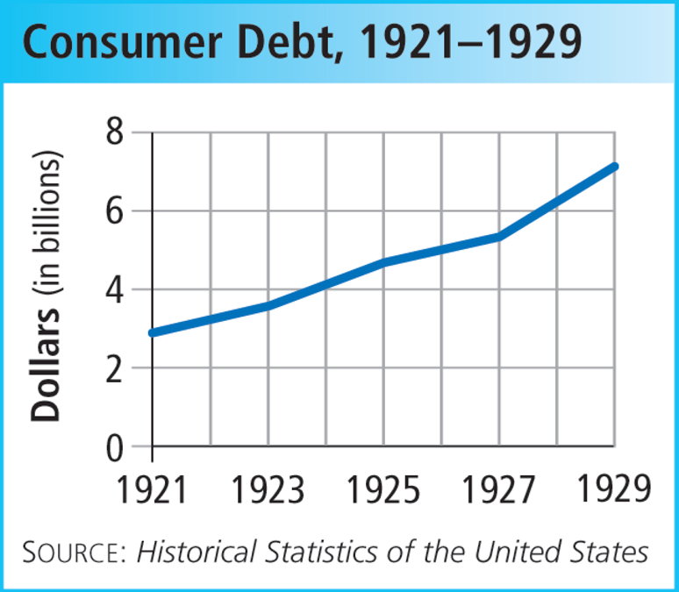

**Document 8:**

|  |  |  |  |
| --- | --- | --- | --- |
| **Stock Prices** | | | |
|  | **Sep. 3, 1929** | **Nov. 13, 1929** | **1932 Low** |
| American Telephone | 304 | 197 1/4 | 70 1/4 |
| General Electric | 396 1/4 | 168 1/2 | 34 |
| General Motors | 72 3/4 | 36 | 7 5/8 |
| New York Central | 256 3/8 | 160 | 8 3/4 |
| Radio | 101 | 26 | 2 1/2 |
| U.S. Steel | 261 | 150 | 21 1/4 |

**Document 9:**

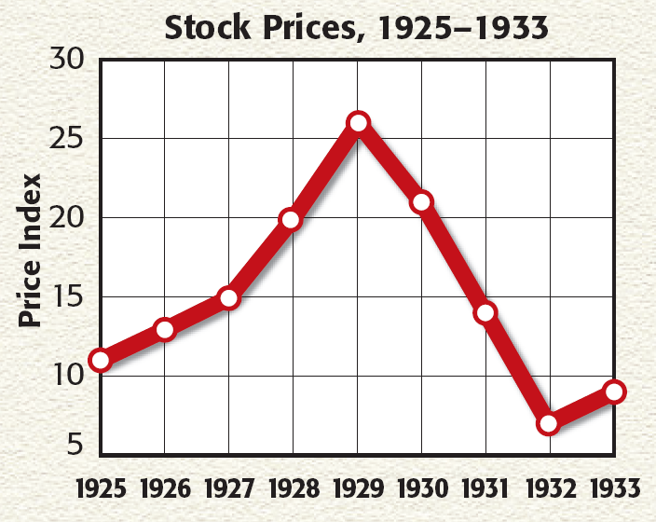

**Document 10:**

|  |  |
| --- | --- |
| **Borrowing to Purchase Stocks as a Percentage of Total Consumer Debt** | |
| 1900 | 1 percent |
| 1910 | 2 percent |
| 1920 | 3 percent |
| 1929 | 5 percent |
| 1933 | 2 percent |

**Document 11: Document 12:**

|  |  |
| --- | --- |
| **Share of Disposable Income Going to the Richest 5 %** | |
| 1920 | 24 % |
| 1921 | 29 % |
| 1922 | 29 % |
| 1923 | 27 % |
| 1924 | 29 % |
| 1925 | 31 % |
| 1926 | 31 % |
| 1927 | 32 % |
| 1928 | 34 % |
| 1929 | 34 % |

|  |  |
| --- | --- |
| **Family Income, 1929** | |
| over $10,000 | 2.3 percent |
| $5,000-10,000 | 8 percent |
| 2,500-$5,000 | 19 percent |
| $2,000-2,500 | 11 percent |
| $1,500-2,000 | 18 percent |
| $1,000-1,500 | 21 percent |
| under $1,000 | 21 percent |

**Document 13: Document 14:**

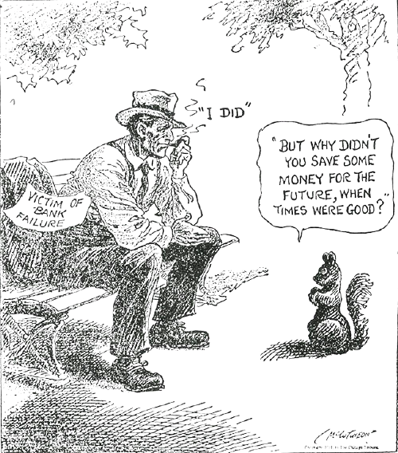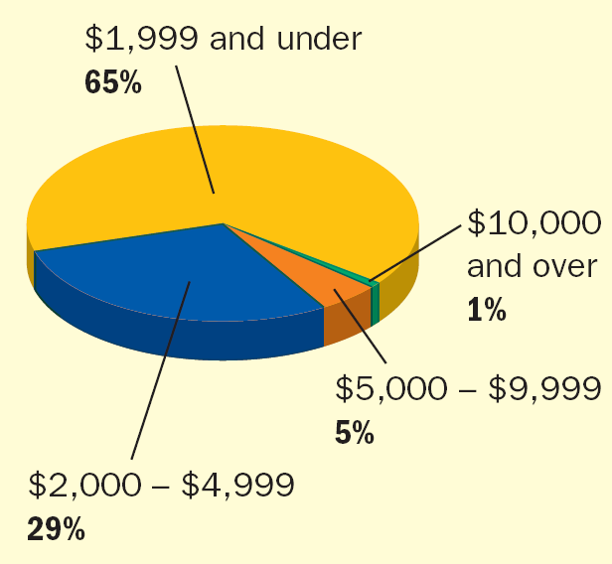

**Document 15:**

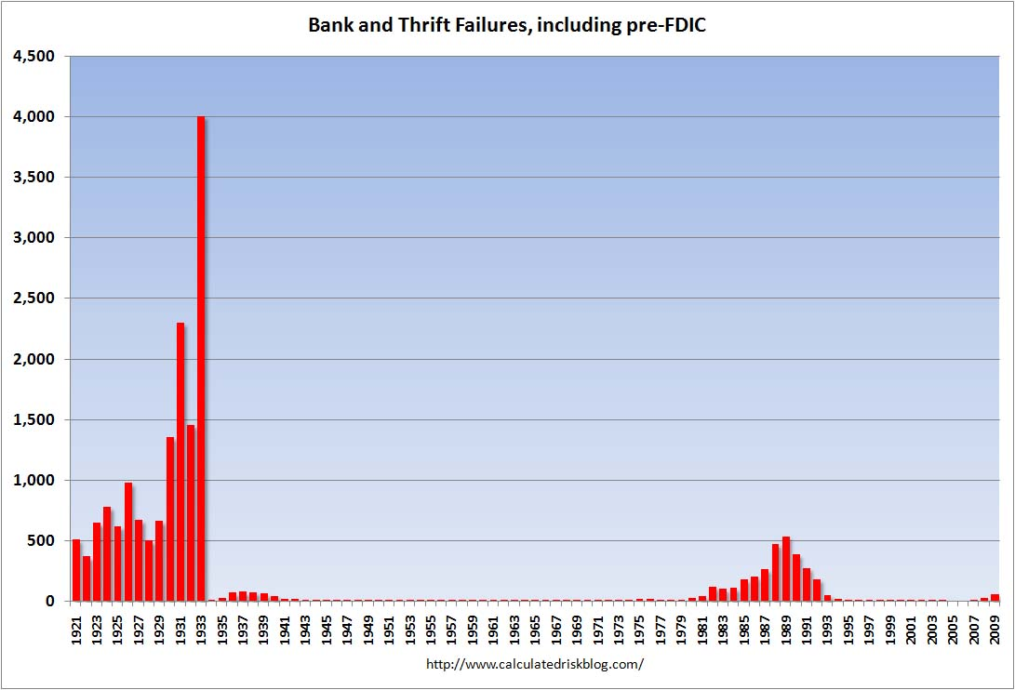

**Document 16:**

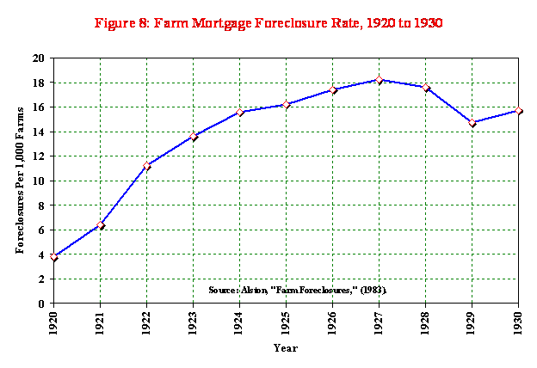

**Document 17 : Document 18:**

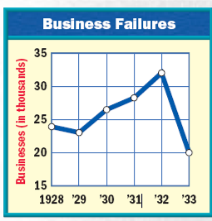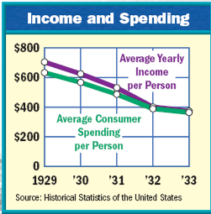

**Document 19: Document 20:**

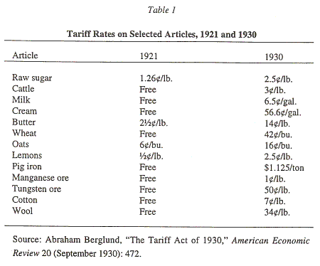 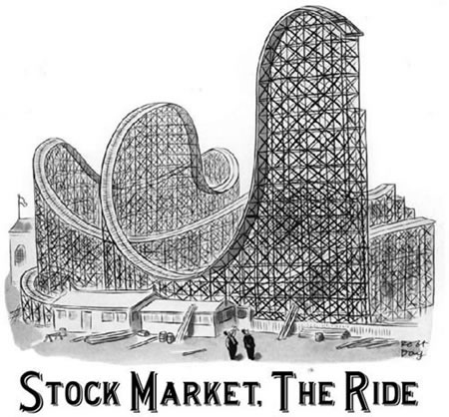

**Document 21:**

