COLUMBIA CITY HIGH SCHOOL
Art Department
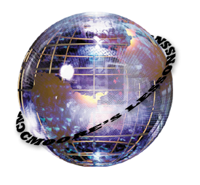
LESSON PLAN By Chad Moore

Lesson: Andy Warhol Portraits

Length: 5 65 Minute Periods

Age or Grade Intended: 9-12th Grade

Academic Standards:

RESPONDING TO ART: History
Standard 1

Students understand the significance of visual art in relation to historical, social, political, environmental, technological, and economic issues.

H.1.1 PROFICIENT: Identify connections between major world events and issues and the ways artists have responded to these through their work.

H.1.3 PROFICIENT: Identify iconography in an artist’s work or a body of work and analyze the meaning.

RESPONDING TO ART: Criticism
Standard 3

Students describe, analyze, and interpret works of art and artifacts.

H.3.1 PROFICIENT: Analyze the effective use of symbols, elements, principles, and media in works of art.
ADVANCED: Analyze how the visual organization of the work affects the communication of ideas and suggest alternatives.

H.3.3 PROFICIENT: Use appropriate art terminology when discussing their own works and the works of others.
ADVANCED: Use appropriate art terminology when discussing their own works and the works of others.

CREATING ART: Production
Standard 7

Students observe, select, and use a range of subject matter, symbols, and ideas.

H.7.2 PROFICIENT: Make informed choices about specific subject matter or concepts and defend those choices when given a range of objects or spaces.
ADVANCED: Select subject matter, symbols, and ideas to communicate personal statements and describe the origin of symbols and why they are of value in artworks.

H.7.3 PROFICIENT: Identify the origin, function, and meaning of symbols used in their work.

Standard 8

Students understand and apply elements and principles of design effectively.

H.8.1 PROFICIENT: Evaluate the effectiveness of elements and principles in works of art and use this evaluation to inform their own work.
ADVANCED: Create multiple solutions in works that demonstrate competence in producing effective relationships between elements, media, and function.

H.8.2 PROFICIENT: Create works of art that use specific principles to solve visual problems.
ADVANCED: Create works that use specific elements, principles, and functions to solve problems and communicate ideas.

Performance Objectives:

Students will:
- Gain an understanding and appreciation for the work of Andy Warhol
- Be able to create a poster that illustrates the style of Andy Warhol
- Students examine examples of Warhol's work for ideas about applying his style of color choice and contrast to their own portraits.
- Students produce a 4-quadrant "canvas" that they then paint (using photoshop) with appropriate colors/contrasts.

Advanced Preparation by Teacher:
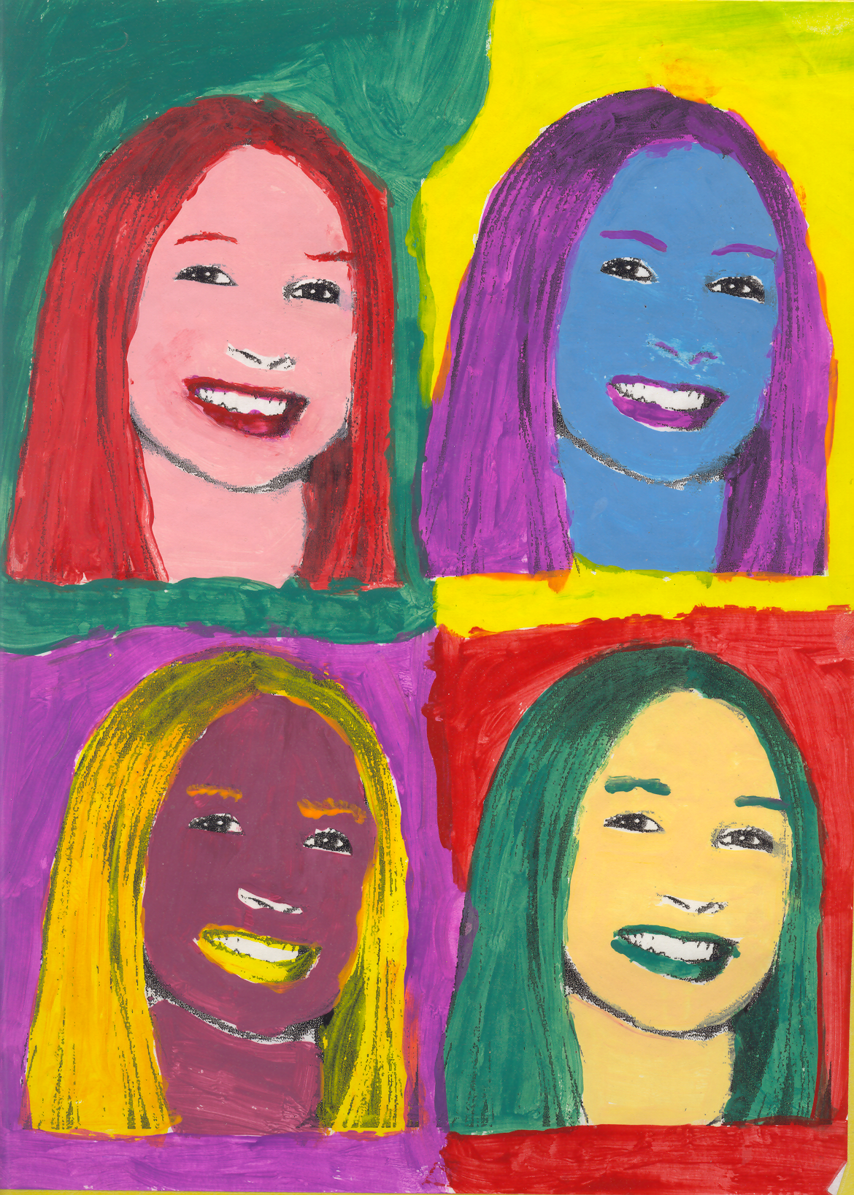
Materials Needed:
Adobe Photoshop Software
Internet Access
Printer
Photos

Resources:

Andy Warhol, 1996,written and illustrated by Mike Venezia, from the Getting to Know the World's Greatest Artists series, Children's Press, Grolier Publishing, New York, ISBN 0-516-26075-8
Andy Warhol Museum http://www.warhol.org/
About Art History http://arthistory.about.com
Andy Warhol@ the NGA http://www.nga.gov/cgi-bin/pbio?32670
Marilyn Image - allows you to experiment with color choice and contrast - very cool - http://webexhibits.org/colorart/marilyns.html

Acrobat Reader may be required to view one or more links on this page. If it is not installed on your computer, you may download a free version at this site: http://www.adobe.com/products/acrobat/readstep.html

Procedure:

Introduction/Motivation:
Students are introduced to Andy Warhol's work through a Power Point and self research project. A class discussion about pop art and Warhol's style follows the introduction.

Step-By-Step Plan:
During the powerpoint, pause as needed to fill in details about Andy Warhol using information that students have researched. - discuss a definition of pop art and cultural art. Mention that Warhol had many people working for him to produce his works, and discuss the questions, "What is art?" and "What is an artist?" Before the discussion, be familiar with two benchmarks, so that your information and questions are directed toward these: 1) Describe the origins of specific images and ideas and explain why they are of value in their artwork and in the work of others, and 2) Describe the functions and explore the meaning of specific art objects within varied cultures, times, and places.
Explain to students that they will be creating self-portraits in the style of Warhol, using his sense of color and repetition.
Focus Questions:
What is pop art and what is its significance? How can the style of Andy Warhol be applied to self portraits? How can current technologies be used to produce a Warhol-style artwork?
- Have each student take a partner’s photography using a plain white background.
- Download photos so that each student has access to their own photo.
- Using layer masks and difference layers create a Warholesque portrait. Each document should fit to 17x11 paper.

Closure
Evaluation:
1. Students complete self-assessment.
2. Hold a classroom critique in which students can express their thoughts and feelings about their work.

Adaptations/Enrichment:

Enrichment
Have a student create a powerpoint illustrating the work of Andy Warhol and some of his disciples.

Self Reflection:

This project helped students understand Soup-Can-as-Art a little better. Also, through the art history project in which they each studied an artist, they had become aware that many artists do self-portraits, and they enjoyed trying a self-portrait.

